**Exp No: 10**

10. Writing triggers

*show databases;*

*use db;*

*show tables;*

*create table cust(name varchar(2) primary key, salary int);*

*desc cust;*

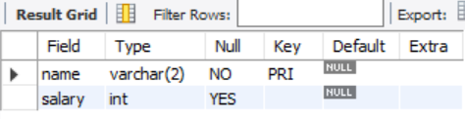





*insert into cust(name, salary) values("VK", 24000);*

*insert into cust(name, salary) values("GK",15000);*

*insert into cust(name, salary) values("KA",34000);*

*select * from cust;*

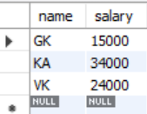



*create table cust_data(name varchar(2), salary int);*

*desc cust_data;*

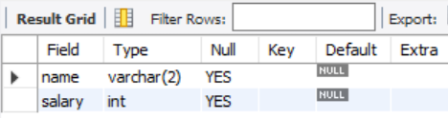



*create trigger D*

*before insert*

*on*

*cust*

*for each row*

*insert into cust_data*

*set name = new.name,*

*salary = new.salary + 10000;*

*insert into cust values ("OP", 50000);*



*show triggers;*



*select * from cust;*

*update cust set name = "KA" where name = "VS";*

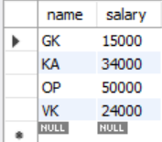



*select * from cust_data;*

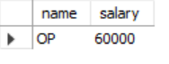



*show triggers;*

